Rokas Pazera

Week 1

Assignment 1 –C4 basics
System context (level 1) – shows the big picture, like software system, users and external integrations or systems.
Container (level 2) – shows separate deployable units like web applications, databases
Component (level 3) – shows a single container, like a web server, or API
Code (level 4) – shows a low-level design details, like class diagrams or code structures.

Assignment 2 – applying C4

1. Order management handles shopping carts and payments. (level 3)
2. A publisher provides new book data. (level 1)
3. The class Book contains properties such as title, author, and price. (level 4)
4. The database stores user data and book information. (level 2)
5. A user searches for and buys books through the platform. (level 1)
6. The search service processes queries and filters. (level 3)
7. The class OrderService has methods createOrder() and cancelOrder. (level 4)
8. The platform connects with an external payment service for transactions. (level 1)
9. The web app displays books and the shopping cart to the user. (level 2)
10. The API server processes orders and manages communication with other systems. (level 2)
11. The authentication component handles login and registration. (level 3)
12. The class UserRepository retrieves user data from the database (level 4)

Assignment 3 – use cases

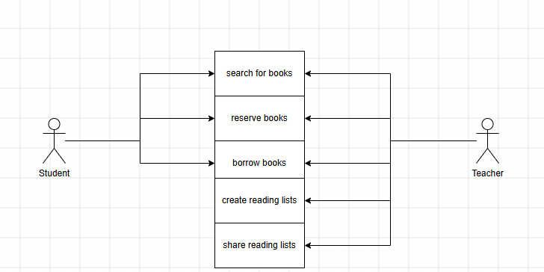

Assignment 4 – deployment diagram

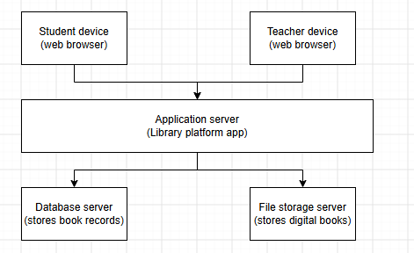
Student/teacher device – their laptop/phone running a web browser.
Application server – computer that runs the library software. It handles searching, reserving and borrowing books.
File storage server – a separate computer that stores the digital book files. These are kept apart from the database, because these large files and their backups would make database slow.

Assignment 5 – component diagram

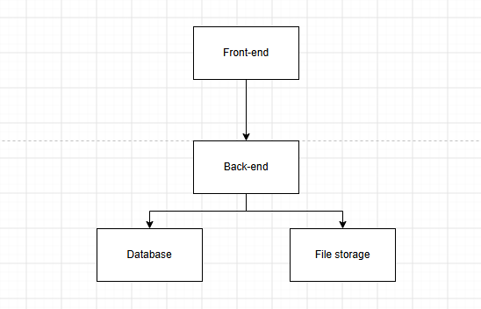

Front-end – handles search results, reservation buttons, reading lists.
Back-end – processes reservations, lets teachers to create and share reading lists.
Database – stores structured data (books, users, reservations, borrow history, reading lists)

Week 2
Coloring:
Gray – Actor
Blue – Something we built
Red – database
Green – outside the system

Assignment 1 – C4 Context
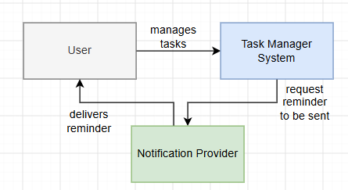

Assignment 2 – C4 Containers
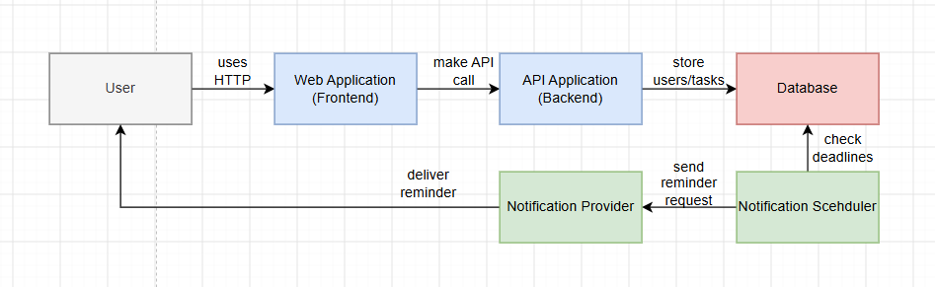

Assignment 3 – C4 Components
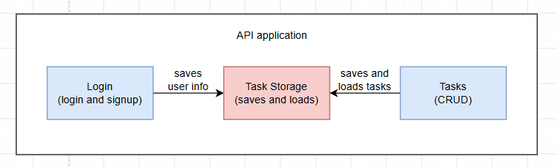
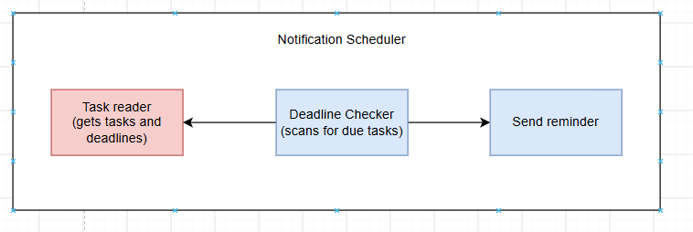

Assignment 4 – From C4 to Component Diagram

